**Llamera, Justine L.**

**2BSIT-3**

**CIT223-18/ITL223-18 - Information Management 2**

**Lab Assignment 2**

***Query 1: Sales Order Shipments by Month and Category Code1***

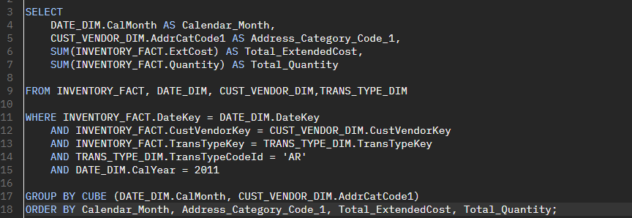

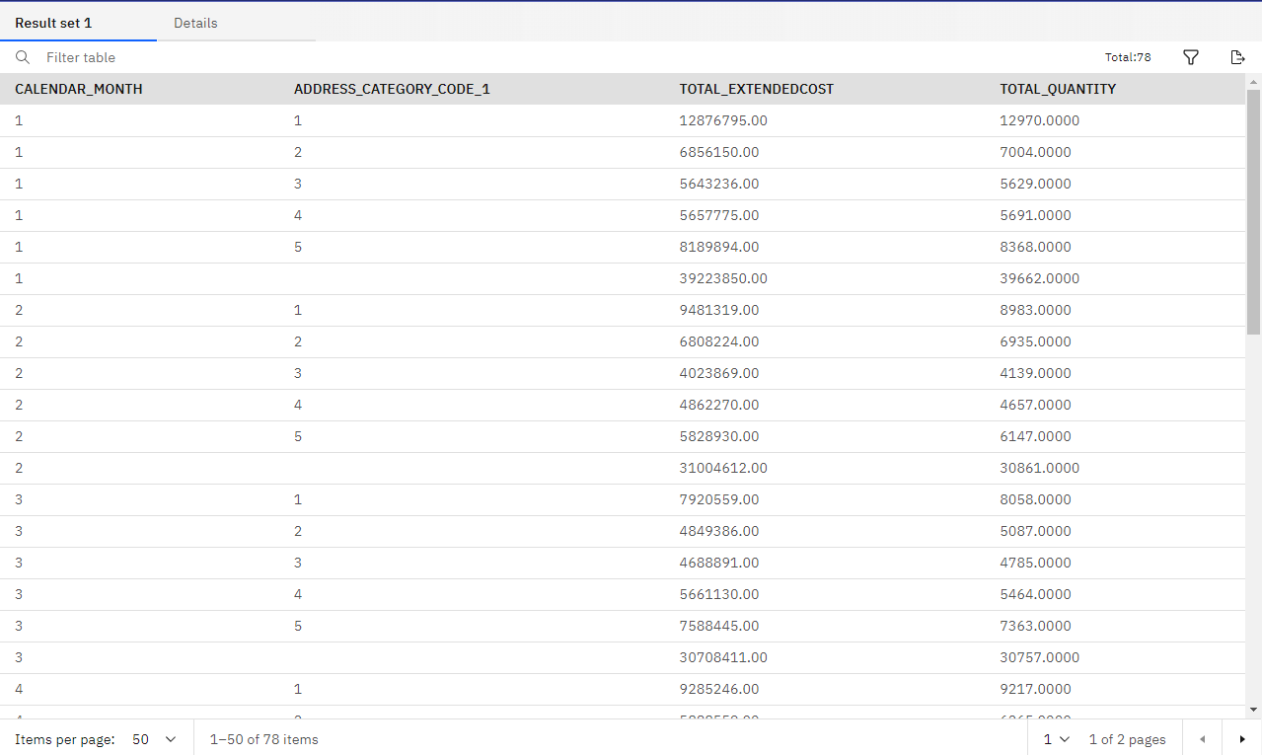

## *Query 2: Sales Order Shipments by Name, Zip, and Quarter*

## 

## 

## *Query 3: Transfers by Company and Branch Plant*

## 

## 

## *Query 4: Inventory Transactions by Transaction Description, Company, and Branch Plant*

## 

## *Query 5: Adjustments by Part Number*

## 

## 

## *Query 6: Rewrite Query 1 without CUBE, ROLLUP, or GROUPING SETS*

## 

## 

## 

## 

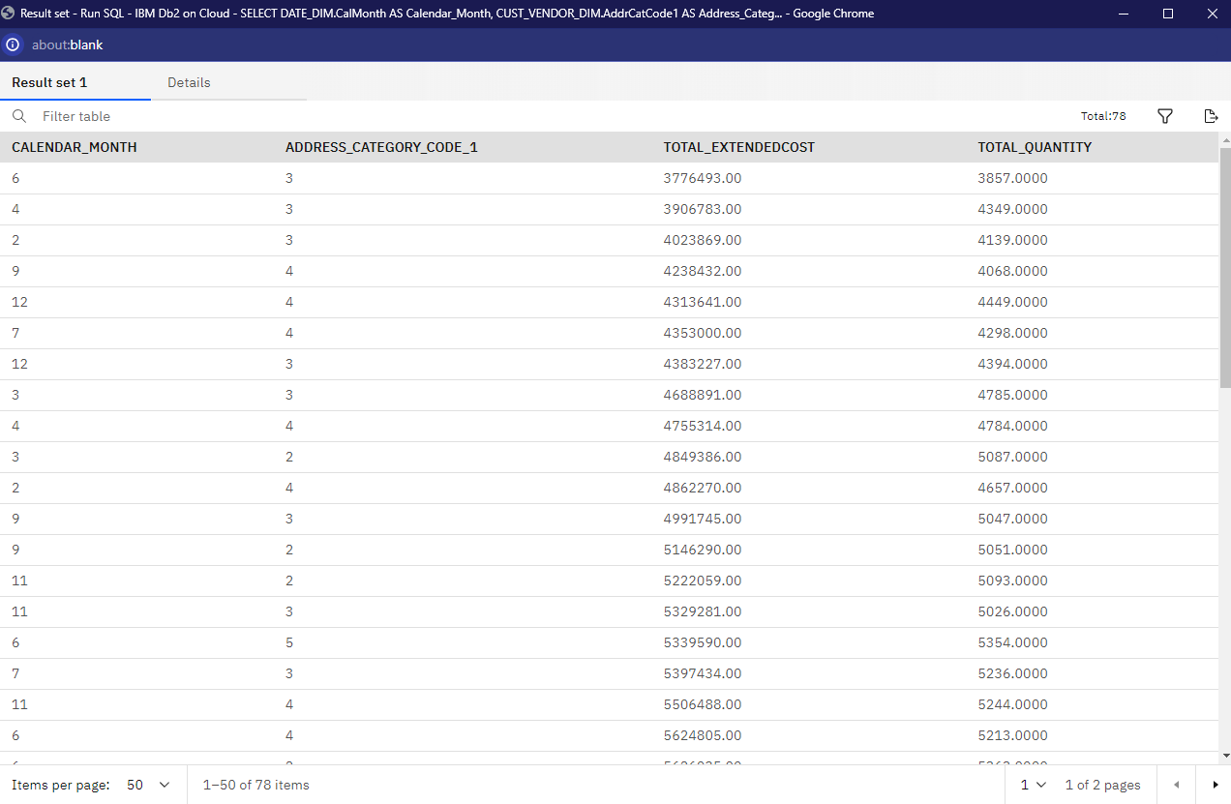

***Query 7: Rewrite Query 3 without CUBE, ROLLUP, or GROUPING SETS***

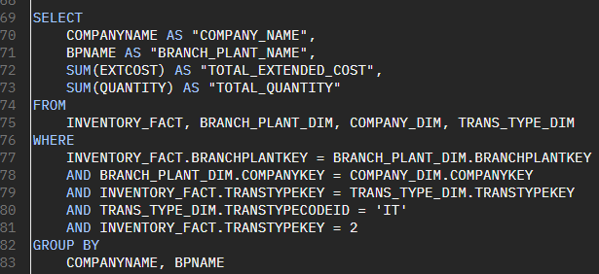

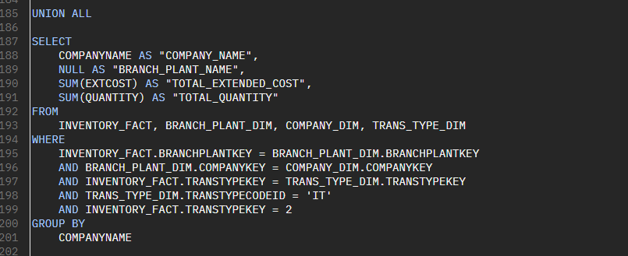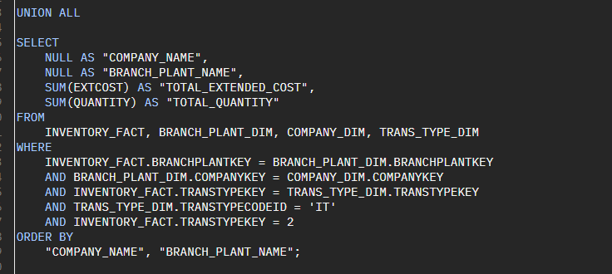

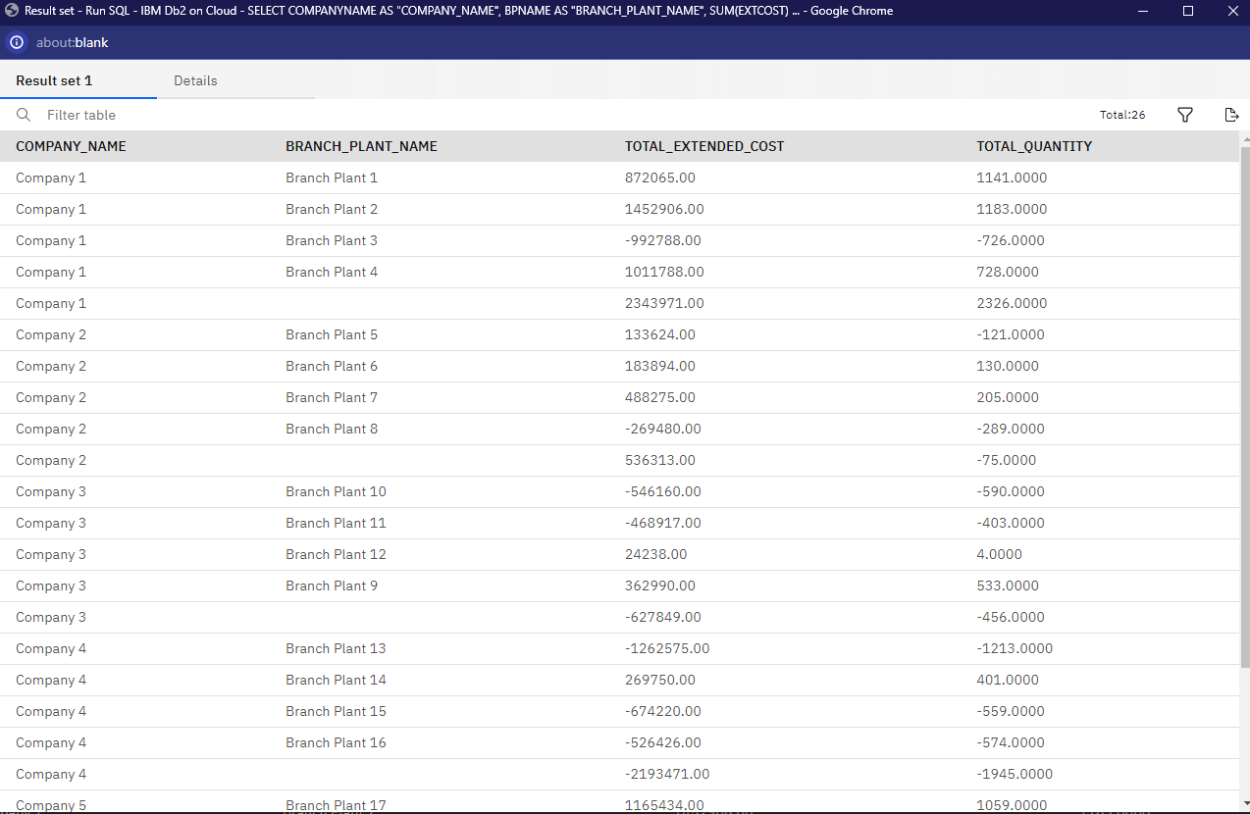

***Query 8: Sales Order Shipments by Name and Combination of Year and Quarter***

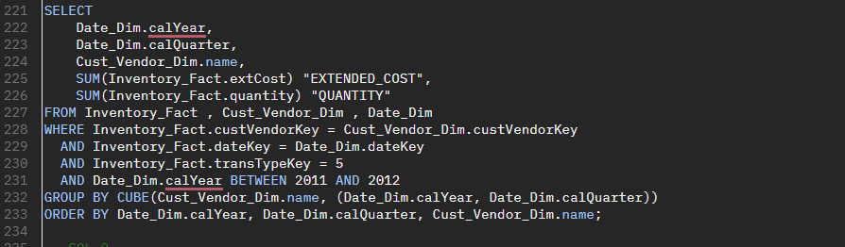

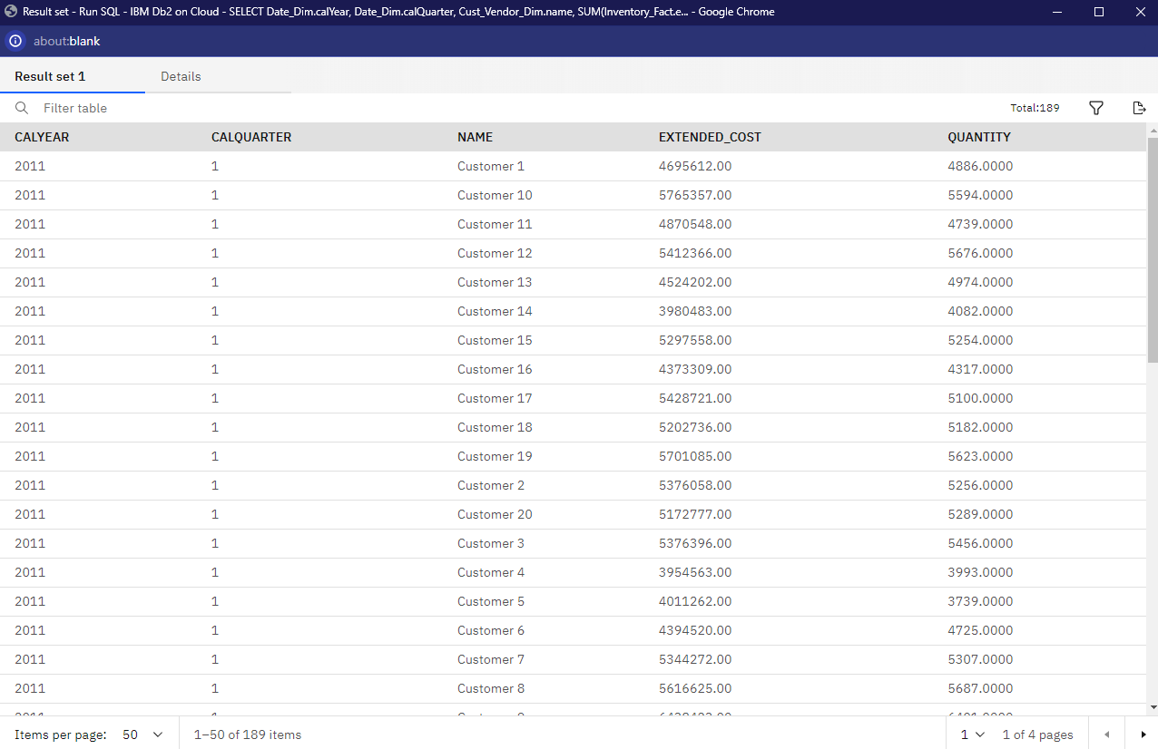

***Query 9: Sales Order Shipments by Month and Category Code1 with Group Number***

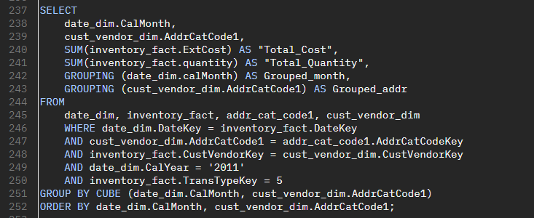

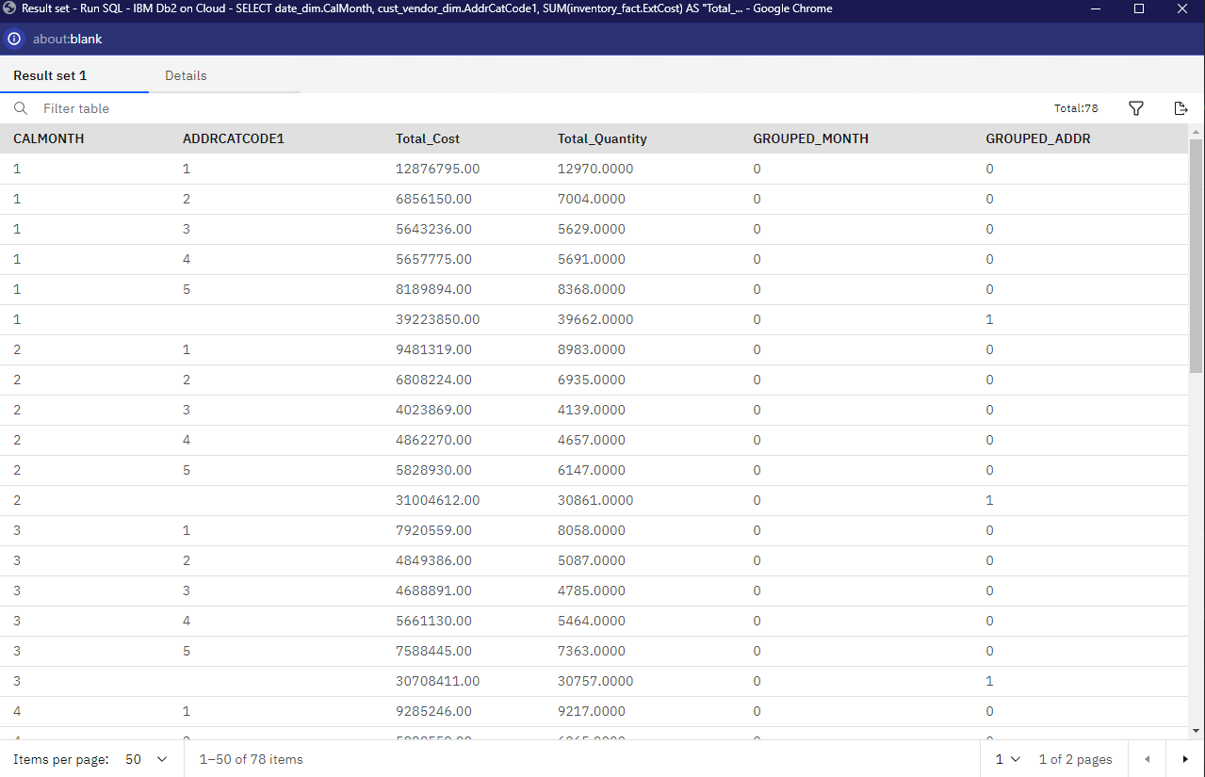

***Query 10: Sales Order Shipments with Subtotals by Name and Partial Subtotals by Year and Quarter***

